# Markov Chains

## Assumptions

All XYZ falls into N categories : list. This is because in reality, this encompasses the vast majority, so this assumption can be made for the purposes of model simplification.

**The Markov assumption -** the state at a time, t, only depends on the state in the previous time interval, t-1. Discretise time.

Fixed population size

Any calculated transition probability needs to be clearly justified.

## Model Development

The Markov chain is a mathematical object that uses matrices to find stationary states in probabilistic systems.

3 components of a markov chain situation:

* State space: There exists a finite set of all possible states for the system to assume
* Markov assumption - the current state of XYZ only depends on the prior state of XYZ
* 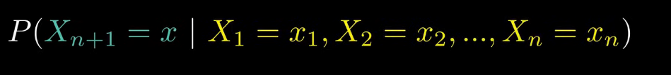
* 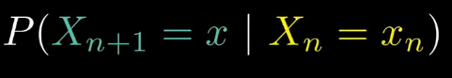
* Where big X is the variable representing the state after the subscripted number of days, and little x represents the state being considered.
* Transition Matrix - the rows are the state on t-1, and the columns are the state on t. It tells us the probability of transitioning from the state described by the ith column to the jth row.

The set of states and transitions between states can be represented by a Markov chain diagram, where transition arrows originate from the current state and point towards the future state, weighted by probability, such that the sum of outgoing arrows from any given state must equal 1.

(IMAGE OF OUR SPECIFIC MARKOV CHAIN)

Initial state is represented by a vector, with each column representing the number of XYZ present in each state at the start.

The initial vector, when multiplied by the transposed transition state matrix, yields the vector representing the distribution after one discrete time being considered.

This way we can simulate a random walk (repeated matrix multiplication).

Idea of a steady state:

If this process is iteratively applied, the vector may tend to a ‘steady state’. The eigenvector for the transition matrix. To avoid iterative methods,

(Eigenvector condition)

From here stationary distribution of states can be found.

BREAK OF MARKOV CONDITION

Probability MAY be dependent on t, time, to account for changing transition probabilities. Compared to the logistic model. Ensure column stochasticity.

Alpha tends towards something.

IDEA plot previous trend in transition probability across years, show there is a high volatility and little room to predict it, so assume it is constant

## Advantages

The use of Markov chains allows us to be able to model complex relationships and

changes between XYZ.

## Disadvantages

In using the Markov chain model, we assume that the initially observed trends would always be constant, making our model inflexible to more drastic changes that can be found in the long term. We also can not account for time dependent transition probabilities, resulting in a simpler, yet reductive model.

Doesn’t account for population growth

## Sensitivity Analysis

Increase percentage by x%, decrease another by x%. This ensures that our probability matrix is still column stochastic, as that column will still add up to 1.

# **Meyer Notes**

* We input transition matrix and initial distribution of the states
* Transposes the transition matrix (To make it simpler to calculate the next state)
* Multiples this matrix with the vector of the distribution of the states to calculate the next state - repeats for as many years as needed
* To draw markov chain in LaTeX see:

https://www.overleaf.com/5367738373jzbbkdbnwxqx#51131f